Suggested List of Clothing

KIT LIST
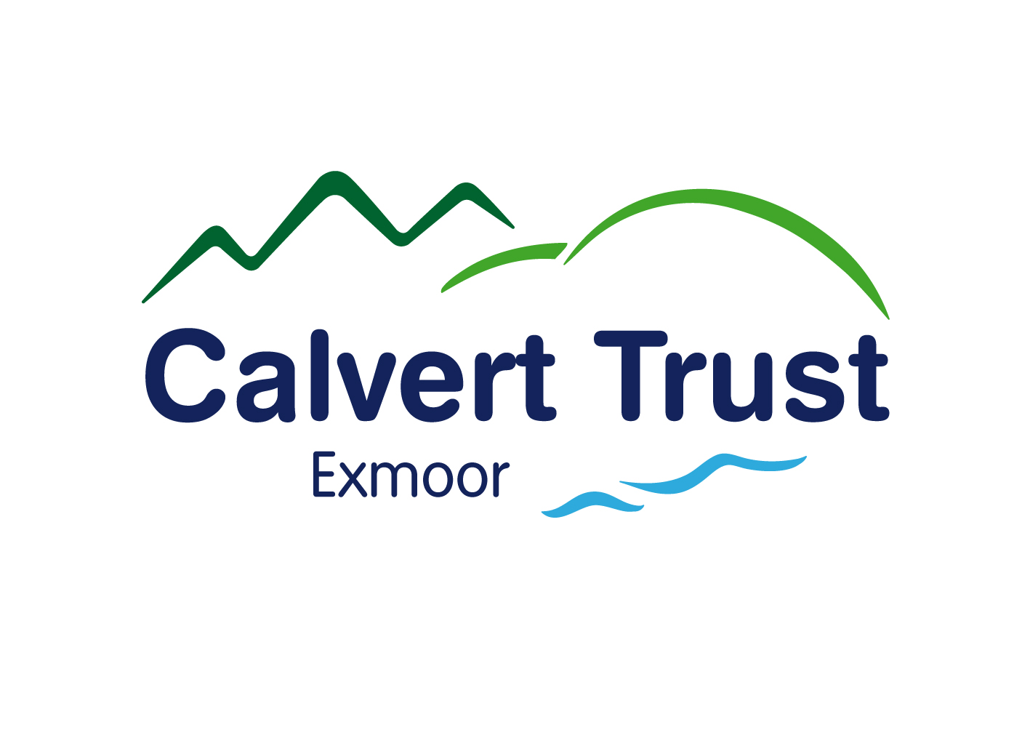

Waterproof Jacket & Trousers - If you have your own

Warm Jumpers - A number of thin sweaters are better than one thick
sweater

Warm Trousers - 3 pairs. Jeans are not suitable for outdoor activities,
tracksuit trousers etc. are more comfortable.
Full-length trousers are required for horse riding – you will not be allowed to ride in shorts.

Warm Anorak or Coat

Gloves, Hat & Scarf

Thick Socks

Boots - Walking and/or Wellington boots

Training Shoes (or similar) - Bring at least two pairs - of which one pair may be used for water sports.

Sturdy Shoes - With heel for horse riding (horse riding is not available for weekend breaks)
Casual Clothes - For evening use

Swimming Costume & Towel - And goggles if needed

Towels - Towels are not provided by the centre

Sun cream, Sunglasses, Sun hat/ Baseball cap

Alarm clock/ watch

If you need to wear glasses on activities you may like to purchase a lanyard or Croakie

All articles of clothing should be clearly labelled
Lost property not claimed will be disposed of after 3 months

We provide the following equipment
(But if you have your own you may prefer to bring it with you)

Day Sac

Riding Hats

Life Jacket/Buoyancy Aids

Specialist Outdoor Equipment

